**Markers :**

Markers enable you to implement print device (tray selection, simplex/duplex settings, watermarks)

in your document. Section-level markers implement print device functions on a section of content

in your documents. Section-level markers override output stream-level markers.

* Markers are maily used in FMS letters
* KIT`s will have Duplex printing

**Printer definition :**

Markers which are defined in the printer definition are listed below

There are two types of markers

1. Media – includes color type options
2. Non Media – includes simplex and duplex config

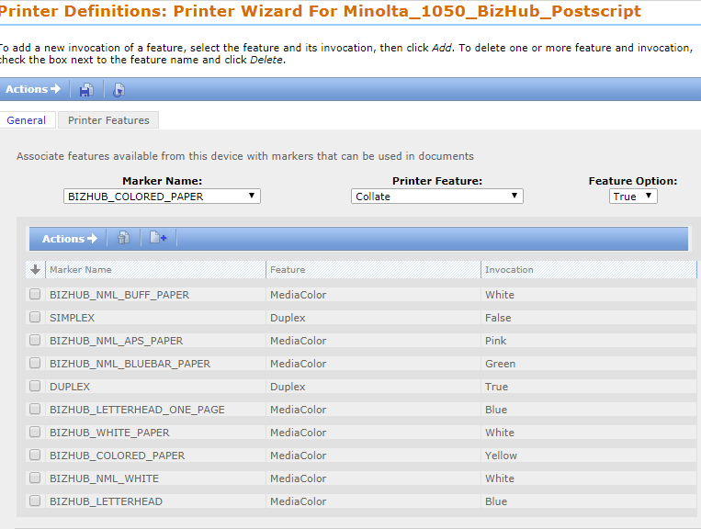

**Steps to unit test simplex/ dulplex mechanism in a PS File:**

1. Open the PS file in notepad++ or any application which has read mode
2. Search for “Page:”
3. If the duplex option is enabled for the particular page, <duplex> tag will be set to true.
4. Color options can also be tested in the same way by checking the <color> tag.

**Markers configuration can be customized in marker definition as shown below.**

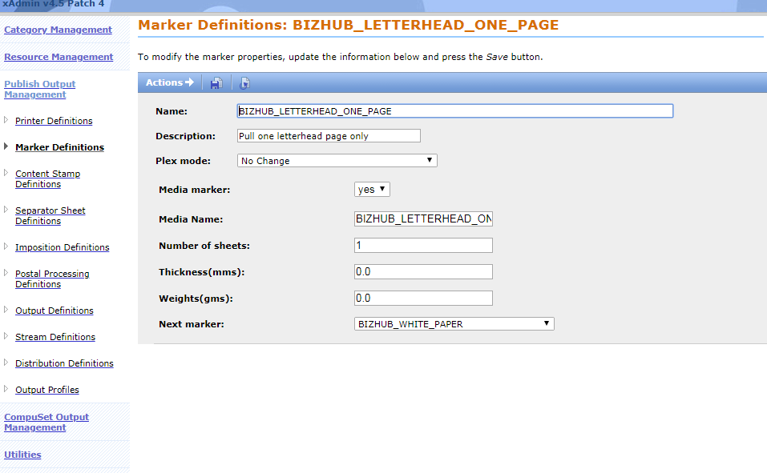

* BIZHUB LETTERHEAD ONE PAGE marker will be applicable for the first page alone and the next page will have BIZHUB white paper marker

**Markers which are defined in Output Stream :**

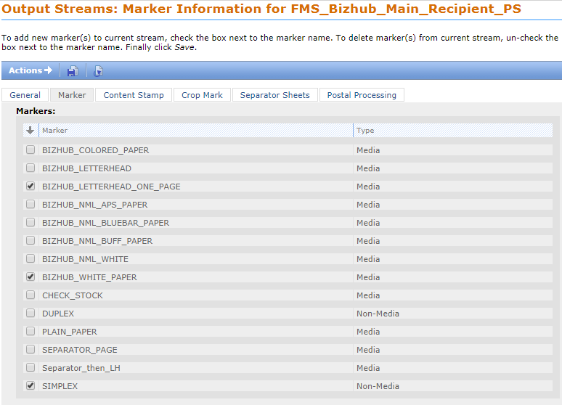

**Markers which are defined in Section :**

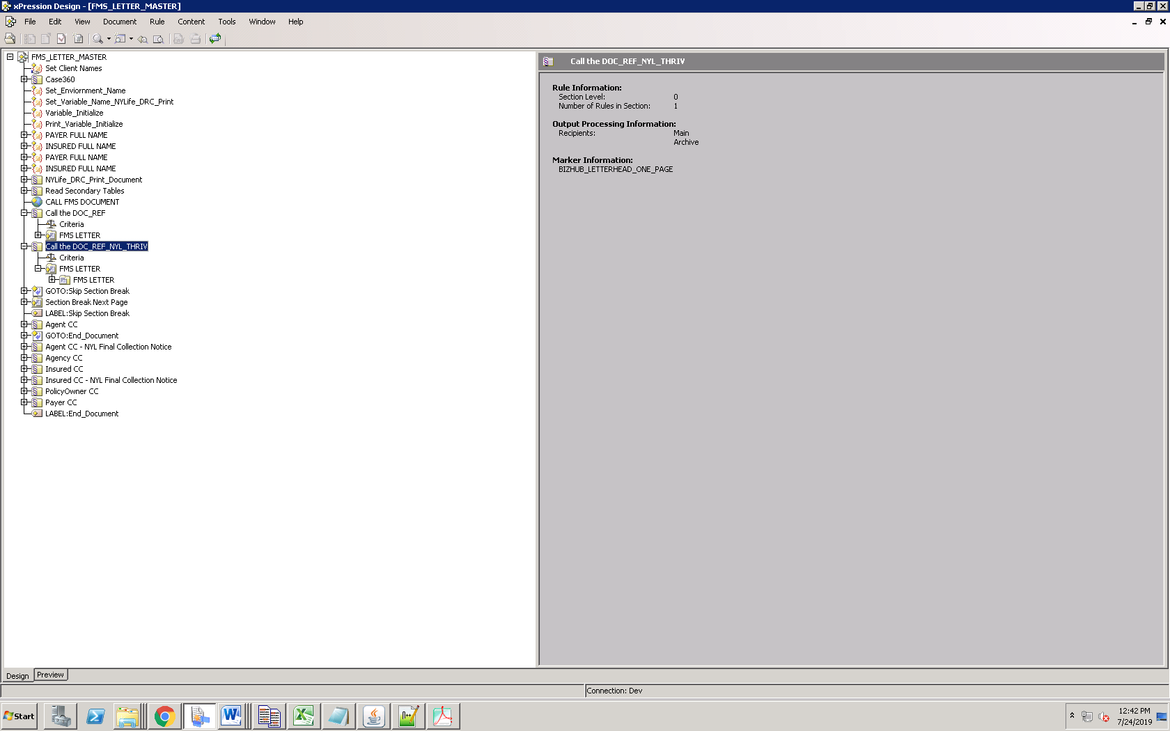

For example, BIZHUB_LETTER_HEAD_ONE_PAGE is applied in FMS Letter for NYL, THRIVENT and Metlife

